Lesson 15 Exercise

In Camp TEKKLA in Sector 1 of UNAC mission in CARANA, the Force intends to deploy two new companies as part of a surge which has been mandated to prepare for the upcoming election.

One of the companies will be a Force Police Unit (FPU) and the other company will be a quick reaction force of military personnel.

The main government opposition candidate in the elections is a former rebel turned politician.

The opposition party have been very critical of the UNAC mission saying that the peacekeepers are doing more damage to the country than good.

They highlight the case of the spread of Welly Belly; a rare disease which has ravaged the country and has been claimed to be introduced by some of the peacekeepers.

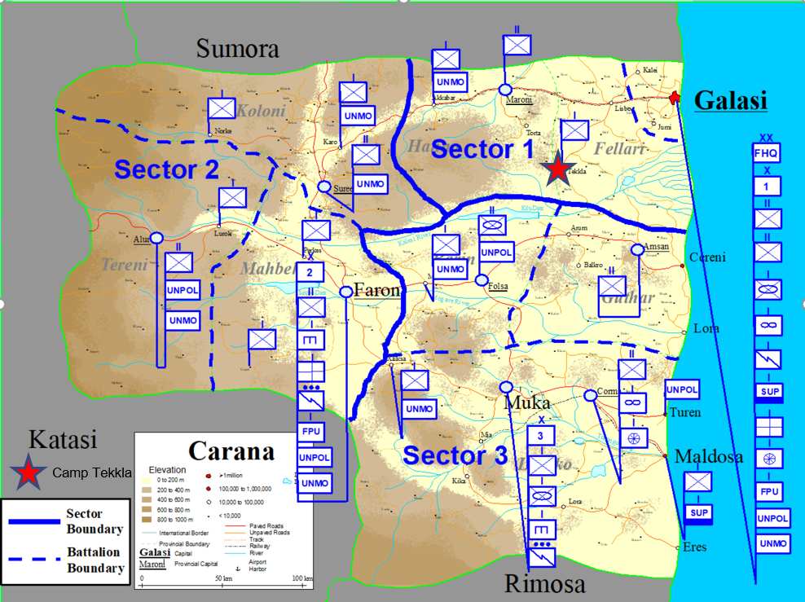

Last year during the rainy season half of the TEKKLA camp area was flooded by over 1m of water. The country is prone to heavy lightning and thunderstorms.

The new units will each need to maintain one platoon at a 1 hour notice to move.

A second platoon must be on a 3 hour notice to move

The remainder of each unit will be on a 24 hour notice to move.

The FPU have 4 public order platoons, each with 5 shotguns, 30 tasers, 5 grenade launchers and one sniper rifle. One security platoon with 30 rifles and 4 shotguns and one community engagement platoon with 30 pistols. The FPU also maintains a pool of 30 pistols for officers as needed. The FPU also have 3 working police dogs.

The QRF has a typical company weapons requirement with 150 personnel weapons, 3 mortars, 20 RPG launchers and 4 sniper rifles.

**Deliverables**

1. Prepare a risk assessment for the deployment of these units to Camp TEKKLA (camp only, not the movement of the reinforcing units)
2. The assessment should be used to then generate a storage plan for the weapons
3. The required mitigation measures such as fencing and additional security measures must be clearly highlighted